Turbo blowers
Oil-free, efficient, reliable
Pillaerator turbo blowers from Kaeser Kompressoren are the ideal choice for high air demand aeration processes in biological water treatment applications. Using cutting edge technology, they provide energy-efficient and reliable operation to assure low life cycle costs.
With flow rates from 50 to 275 m³/min and differential pressures up to 1.3 bar, Kaeser turbo blowers can be used wherever low pressure process air is required. Turbo blowers provide the perfect solution for delivery of large volumes of air necessary for aeration in industrial and municipal wastewater treatment settings. They are equally well-suited to other industrial applications, such as flotation, fermentation, fluidisation and the generation of blowing air for air knives.
These machines are not only exceptionally efficient, but are also intelligently designed. The turbo impeller is directly driven by a high-speed motor inside a shaft supported by magnetic bearings, which makes the system completely wear-free. This means no lubrication is required, saving both time and costs when it comes to maintenance. Smart magnetic bearings, which are protected against unexpected power failure, actively control the rotor position so as to maintain it within its orbit, even in the event of fluctuating operating parameters. The bearings operate independently of speed, thereby allowing a wide control range.
Cooling of key components is performed independently of the outside ambient air. They are therefore protected against the ingress of any fine particles, which in turn assures long-term uninterrupted operation. In order to ensure that Pillaerator turbo blowers always operate at optimum efficiency, versions are available for three different pressure ranges: L (600 mbar), M (800 mbar) and H (1000 mbar). Slightly higher pressures are required for special applications.
1,890 keystrokes − Approved for publication, copy appreciated
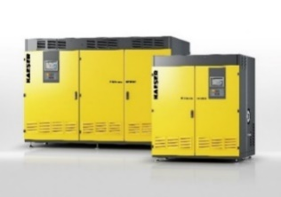

Thanks to contactless and lubricant-free magnetic bearings, Pillaerator turbo blowers from Kaeser provide exceptional efficiency and are completely wear-free.

