**The “Mobilair 13 and 17” portable compressors from Kaeser**

**Portable Power and Efficiency**

**The smallest models in the Mobilair portable compressor range from Kaeser, the “M 13” and “M 17”, combine outstanding power and efficiency with quiet operation and exceptional manoeuvrability. Furthermore, the 15 bar maximum working pressure of the “M 17” makes this compact powerhouse the ideal choice for trenchless laying of glass fibre cables.**

With a free air delivery of 1.2 m³/min at 7 bar, the “Mobilair 13” is no slouch either and is more than capable of powering breakers, drills, saws, grinders, impact wrenches, impact borers or pipe inspection robots. As already mentioned, the 15 bar “Mobilair 17” is perfect for trenchless laying of glass fibres and delivers an impressive 1m3 of compressed air per minute. Moreover, the highly versatile “Mobilair 13” is also available in 10-, 12-, and 13-bar versions.

An air-cooled, 4-stroke Honda petrol engine drives the screw compressor unit via a maintenance-free V-belt drive system. The M 13 and M 17 are also equipped with a generous 20-litre capacity fuel tank that enables uninterrupted operation during long work shifts and eliminates the need for frequent refuelling. A continuous air delivery control system precisely matches compressor performance to suit actual compressed air demand, which further reduces fuel consumption of these already highly efficient compressor units.

An emission-free electric version with three-phase motor is also available and is therefore ideal for use in closed working environments on the construction site or in the workshop.

All models feature a corrosion- and impact-resistant sound enclosure made from rotation-sintered polyethylene that ensures maximum durability and super-quiet performance.

As this compressor is so compact and lightweight, it can be easily transported in any delivery vehicle, or on the loading floor of a truck or pick-up, leaving the vehicle’s tow coupling free for use.

In addition, the compressor can be equipped with an external compressed air aftercooler, either with or without a microfilter combination, for certain applications that may require cool and condensate-free, or even technically oil-free, compressed air. The aftercooler is installed in a frame equipped with fixed connections for compressed air, condensate return and electrical power (12 V supply from the compressor) to drive the aftercooler fan. Accumulating condensate is vaporised with help from the hot engine exhaust or, in the case of the electric version, is collected in a canister.

The “M 13” and “M 17” are also especially user-friendly when it comes to maintenance and handling: Manoeuvrability on the construction site is made simple thanks to the long handle, rugged wheels with pneumatic tyres, four convenient lifting-lugs and a counter-sunk crane eye. Last but not least, maintenance tasks are easy to carry out, as the wide-opening sound enclosure enables excellent component accessibility.

**File: C-M13-17-en**

2.983 keystrokes  Approved for publication, copy appreciated

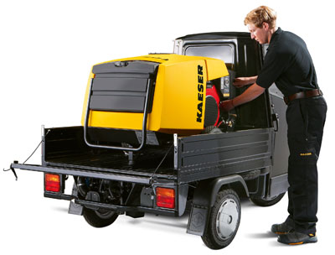

Powered by a quality petrol engine from Honda, the versatile “M 13” portable compressor from Kaeser combines quiet performance with exceptional efficiency. An emission-free electric version with three-phase motor is also available.

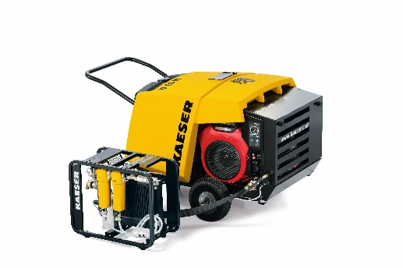

New features: handy support frame with compressed air aftercooler and microfilter combination for technically oil-free compressed air.