Sigma Air Utility
Just buy the compressed air!
Always have the most efficient compressed air supply at your disposal and only pay for actual consumption. Rather than purchasing an entire compressed air station, just buy the compressed air that you actually use – it’s easy and cost-effective with KAESER’s Sigma Air Utility contracting model.
Compared to operating a conventional compressed air station, contracting models such as Sigma Air Utility from Kaeser Kompressoren offer a wide range of user benefits. The customer can immediately enjoy the advantages of a cost-effective, energy-saving compressed air supply with no need for initial capital investment. Planning, installation and operation according to the customer’s requirements and instructions are the responsibility of Kaeser Kompressoren. This allows users to save 100% of the investment cost of a compressed air station and removes the burden of having to allocate staff and funds for maintenance and servicing work. In addition, contracting models provide important tax advantages: by obtaining compressed air at a contractually established price per cubic metre, fixed costs are converted into variable operating costs, which can immediately be claimed for tax purposes. As a leading compressed air solutions provider, Kaeser Kompressoren assures maximum air system efficiency and reliability at all times. Naturally, it is also in Kaeser’s interests to continually adapt the station to meet changing operating conditions and to incorporate the very latest technological innovations.
There are also significant advantages when it comes to maintenance. The Sigma Air Utility compressed air station from Kaeser is constantly monitored via the Sigma Air Manager 4.0 compressor controller and its built-in connection to the Kaeser Service Center. This effectively ensures maximum efficiency and compressed air availability whilst enhancing production reliability.
Users who decide to purchase only the required volume of compressed air at the quality they require – instead of a compressed air station – allow their business to benefit from improved cost transparency. Instead of a composite calculation, they can rely on the fixed price per cubic metre of compressed air, which is contractually agreed well into the future, thereby serving as a reliable basis of calculation. The basic price set for the entire term of the contract covers system and operating costs, as well as consumption of a mutually-agreed base volume of compressed air. Should consumption exceed that amount, the surplus air charge that has also been contractually agreed is applied. Precise measurements guarantee that users are charged only for the volume of compressed air actually drawn from the system.
Sigma Air Utility represents a highly attractive option for compressed air supply when rapid energy efficiency improvements are desired: in this case and many others, outsourcing offers an elegant solution.
The potential savings that can be achieved with Sigma Air Utility compressed air contracting vary in each case. When a company changes to compressed air contracting, the contracting partner usually installs a completely new compressed air system to ensure full exploitation of any and all potential energy savings. The degree to which compressed air costs are reduced depends on the system being replaced, however it is certainly not unusual for customers to achieve savings of 30 percent and beyond – over the long-term, no less.

File: l-contracting-en
3.478 Keystrokes − Approved for publication, copy appreciated

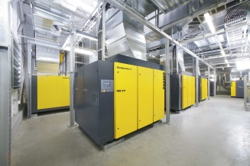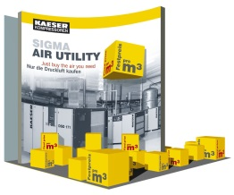
With contracting solutions, the compressed air station remains the property of the system provider. Customers pay only for the volume of compressed air actually consumed.

