Mobilair M 31 portable compressor with PE enclosure
Versatile compressed air powerhouse
Convenient, lightweight, powerful and efficient: These are just some of the key advantages of the Mobilair M 31 portable compressor from Kaeser Kompressoren. With a free air delivery of 3.15 m³/min (at 7 bar), it delivers more air than its predecessor, in addition to offering unique optional features, such as an integrated generator and/or compressed air treatment equipment. A stationary version is also available for specialised applications and can be easily installed on the cargo bed of a truck.
A true powerhouse hides beneath the Mobilair M 31's scratch and corrosion resistant rotation-sintered polyethylene (PE) sound enclosure: The screw airend with energy-saving Sigma Profile rotors is designed for continuous duty and is driven by a powerful, water-cooled Kubota turbo-diesel engine. Consequently, the Mobilair 31 provides a free air delivery of 3.15 m³/min at 7 bar – significantly more than previous models – which makes it the ideal choice for simultaneously powering two 20kg breakers, or other tools such as air lances, spades, impact borers and sandblasting equipment. 7, 10, 12 and 14 bar versions of this to easy to manoeuvre compressor are also available to meet a wide range of requirements. The options don’t stop there however: The Mobilair 31 can be equipped with an integrated aftercooler and centrifugal separator to provide a dependable supply of cool dry air and even a 6.5 kVA generator if required.
There are no worries when it comes to those cold morning starts either: Fitted as standard, Kaeser’s Anti Frost Control protects air tools from potential damage caused by freezing and corrosion. In addition, the wide-opening soundproof enclosure allows quick and easy access to all maintenance points. Another useful option is the hose reel which comes with a 20m lightweight hose, as this enables the compressed air line to be safely stowed away instead of it becoming a potential trip hazard.
2011 keystrokes  Free for publication, copy appreciated _____________________________________________________________

((Caption)):


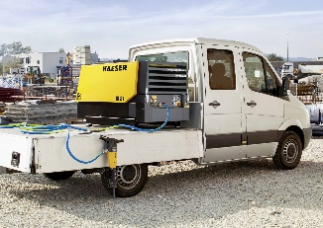

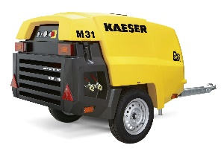

The Mobilair 31 not only delivers impressive performance, but is also available with a wide range of equipment options to ensure maximum flexibility.

((Kaeser photo – Free for publication))

