Powerful, Quiet and Durable
Portable compressor Mobilair 57
The powerful and user-friendly “Mobilair 57” with a maximum air delivery of 5.6 m³/min at 7 bar and a robust, water-cooled, four-cylinder diesel engine the compressor is designed for fuel-efficient hard work. Other features contributing to power-saving and cost effective operation are the Kaeser airend with Sigma Profile rotors and a directly-coupled drive which eliminates power transmission losses.
Furthermore, the Mobilair 57 is equipped with Kaeser’s Anti-frost control as a standard feature, which comes in useful especially in spring and autumn when temperatures are low, because it keeps the air tools from freezing and prevents corrosion, thus enhancing their reliability and service life. As would be expected, the new compressor’s workmanship leaves nothing to be desired; nor do its operability and ease of maintenance: The powder-coated bodywork is made of zinc-primed sheet metal to withstand corrosion and includes an integrated tool chest for air tool storage.

1.037 Keystrokes – Approved for publication, copy appreciated

Images:

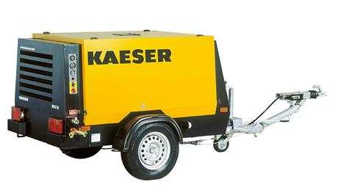

The new portable compressor “Mobilair 57“ fulfils every requirement for a modern construction site air supplier.

