

On-board with the new ESD series
Compact powerhouses
Space on-board ships is always at a premium, which makes Kaeser’s new ESD rotary screw compressors ideal for marine use. Measuring only a metre wide with a footprint of 3.52 square metres, they are significantly more compact than equivalent conventional compressors. Like all Kaeser compressors, they ensure outstanding dependability, power and efficiency.
With drive powers of 200, 250 and 315 kW and covering free air deliveries from 23.3 (1,398 m³/h) to 49.4 m³/min (2,964 m³/h), these versatile compressors are available for pressures from 8 to 14 bar and are the ideal choice for a wide range of applications, such as nitrogen generation for example. Moreover, they are certified by all international marine industry authorities.
Reliability has always been a key requirement for any ships’ compressed air supply system, but so too is efficiency – especially in view of continuously rising energy prices. ESD compressors owe their exceptional efficiency and performance to meticulous engineering and design and save energy in four key ways: First, the airend in every unit features refined flow-optimised “Sigma Profile” rotors for superior efficiency. Second, Kaeser rotary screw airends are powered by IE3 drive motors for maximum performance and reliability. Third, Kaeser’s highly efficient 1:1 drive design eliminates the transmission losses associated with gear or V-belt driven systems, as the motor directly drives the airend. The fourth major energy-saving feature is the newly developed PC-based “Sigma Control 2” compressor controller which enables compressor performance to be precisely matched to actual air demand thereby allowing additional energy savings. Needless to say, this advanced controller is also certified for marine use.
Ensuring that the compressor remains firmly in place no matter how high the seas, the system’s stable base frame is especially designed to be bolted or welded to the ship's deck.
Intelligent component layout means that all maintenance work can be carried out from one side of the unit. The ESD can therefore be installed along the ship’s side or against a bulkhead.
All systems feature a Kaeser centrifugal separator that automatically removes condensate reliably and efficiently via the Kaeser Eco Drain – without energy loss. The separator’s stainless steel compressed air lines protect against corrosion.
Together with the centrifugal separator, a highly effective service water (fresh-water) fed cooling system ensures a constant supply of cool, condensate-free compressed air at all times. An option for cooling via sea water is also available.
In every respect, the new ESD is the perfect partner for all of your marine compressed air needs.

File: A-ESD-marin-Eng
2951 keystrokes − Free for publication, copy appreciated

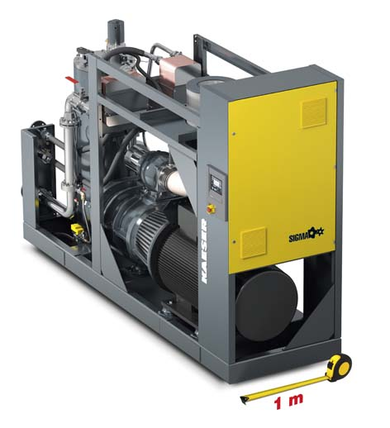

Caption:
The ESD is a compact marine-duty compressed air station. With a width of just one metre and a total footprint of only 3.52 square metres, this powerful, dependable and efficient compressor fits in almost anywhere.

Kaeser factory photo, reprints permitted

